**PF-Lab Project,**

**Muhammad Moosa Nomani,**

**25K-0530**

**SOURCE CODE**

#include<string.h>

#include<stdio.h>

#define MAX_BOOKS 100

#define MAX_STUDENTS 100

#define MAX_ISSUED_PER_STUDENT 3

#define MAX_ISSUED 100

struct Book{

int id;

char title[50];

char author[50];

int quantity;

};

struct Student{

int id;

char name[50];

};

struct IssuedBook{

int studentId;

int bookId;

char issueDate[20];

};

struct Book books[MAX_BOOKS];

int bookCount=0;

struct Student students[MAX_STUDENTS];

int studentCount=0;

struct IssuedBook issuedBooks[MAX_ISSUED];

int issuedCount=0;

void displayMenu();

void addBook();

void viewBooks();

void registerStudent();

void issueBook();

void returnBook();

void viewIssuedBooks();

int findBookIndex(int bookId);

int findStudentIndex(int studentId);

int countIssuedToStudent(int studentId);

int main(){

while(1){

displayMenu();

int choice;

printf("Enter your choice ");

scanf("%d" , &choice);

switch(choice){

case 1:{

addBook();

break;

}

case 2:{

viewBooks();

break;

}

case 3:{

registerStudent();

break;

}

case 4:{

issueBook();

break;

}

case 5:{

returnBook();

break;

}

case 6:{

viewIssuedBooks();

break;

}

case 7:{

printf("Exiting Program. GoodBye!\n");

return 0;

}

default:{

printf("Invalid Choice. Try Again.\n");

break;

}

}

}

return 0;

}

void displayMenu(){

printf("\n--- LIBRARY MENU ---\n");

printf("1. Add Book\n");

printf("2. View Books\n");

printf("3. Register Student\n");

printf("4. Issue Book\n");

printf("5. Return Book\n");

printf("6. View Issued Books\n");

printf("7. Exit\n");

}

void addBook(){

struct Book b;

printf("Enter Book ID: ");

scanf("%d", &b.id);

getchar();

printf("Enter Title: ");

scanf(" %[^\n]", b.title);

printf("Enter Author: ");

scanf(" %[^\n]", b.author);

printf("Enter Quantity: ");

scanf("%d", &b.quantity);

books[bookCount++] = b;

printf("Book added successfully!\n");

}

void viewBooks(){

printf("\n--- Book List---\n");

for(int i=0;i<bookCount;i++){

printf("ID: %d | Title: %s | Author: %s | Quantity:%d\n", books[i].id,books[i].title,books[i].author,books[i].quantity);

}

}

void registerStudent(){

struct Student s;

printf("Enter Student ID: ");

scanf("%d", &s.id);

getchar();

printf("Enter name: ");

scanf(" %[^\n]" ,s.name );

students[studentCount++] = s;

printf("Student Registered Successfully!\n");

}

void issueBook(){

int sid, bid;

printf("Enter Student ID: ");

scanf("%d", &sid);

int issuedToStudent= countIssuedToStudent(sid);

if(issuedToStudent>=MAX_ISSUED_PER_STUDENT){

printf("Student has already issued maximum number of books (3).\n");

return;

}

printf("Enter Book ID to issue: ");

scanf("%d", &bid);

int bIndex = findBookIndex(bid);

if(bIndex==-1 || books[bIndex].quantity<=0){

printf("Book Not Available.\n");

return;

}

struct IssuedBook ib;

ib.studentId=sid;

ib.bookId=bid;

getchar();

printf("Enter Issue Date(e.g. 2025-10-22): ");

scanf(" %[^\n]", ib.issueDate);

books[bIndex].quantity--;

issuedBooks[issuedCount++]=ib;

printf("Book Issued Successfully!\n");

}

int countIssuedToStudent(int studentId){

int count=0;

for(int i=0;i<issuedCount;i++){

if(issuedBooks[i].studentId==studentId) count++;

}

return count;

}

int findBookIndex(int bookId){

for(int i=0;i<bookCount;i++){

if(books[i].id==bookId) return i;

}

return -1;

}

int findStudentIndex(int studentId){

for(int i=0;i<studentCount;i++){

if(students[i].id==studentId) return i;

}

return -1;

}

void returnBook(){

int sid, bid;

printf("Enter Student ID");

scanf("%d", &sid);

printf("Enter Book ID to return");

scanf("%d", &bid);

int found=0;

for(int i=0;i<issuedCount;i++){

if(issuedBooks[i].studentId==sid && issuedBooks[i].bookId==bid){

for(int j=i;j<issuedCount-1;j++){

issuedBooks[j]=issuedBooks[j+1];

}

issuedCount--;

int bIndex=findBookIndex(bid);

if(bIndex!=-1) books[bIndex].quantity++;

printf("Book Returned Successfully!\n");

found=1;

break;

}

}

if(!found){

printf("Issued Record Not Found.\n");

}

}

void viewIssuedBooks() {

printf("\n--- Issued Books ---\n");

for(int i=0;i<issuedCount;i++){

printf("Student ID: %d | Book ID: %d | Issue Date: %s\n", issuedBooks[i].studentId, issuedBooks[i].bookId, issuedBooks[i].issueDate);

}

}

**SAMPLE OUTPUTS**

**OUTPUT#1:-**

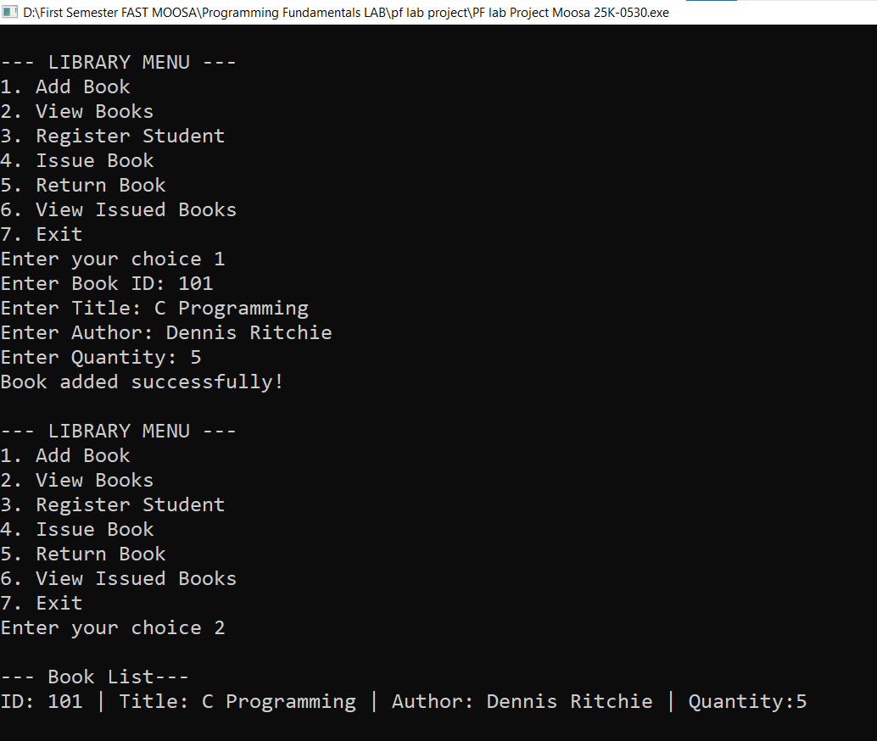

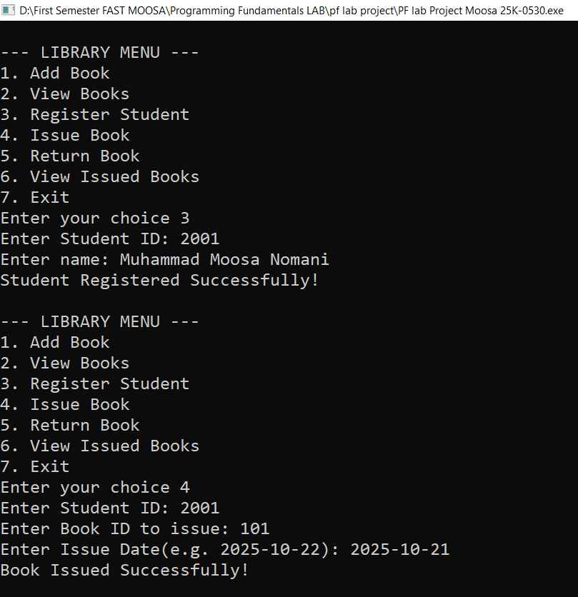

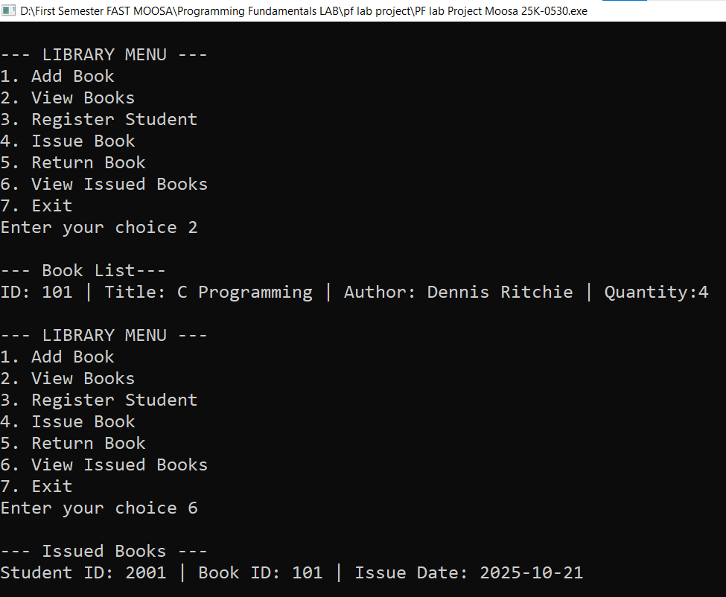

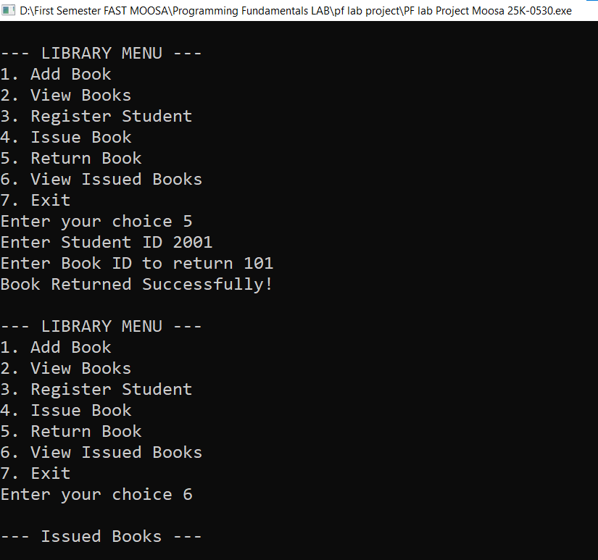

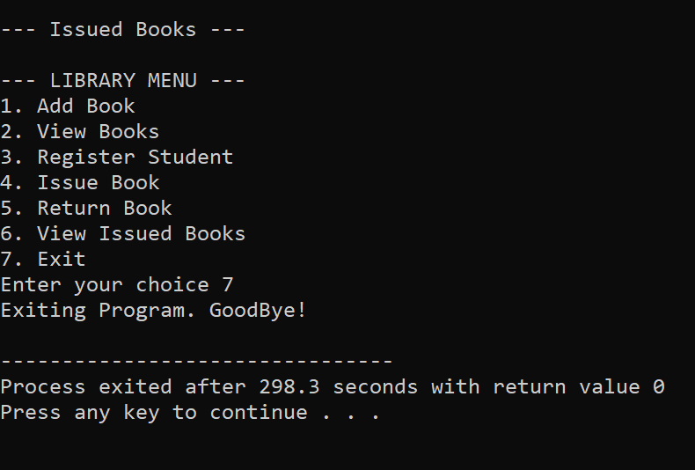

**OUTPUT#2:-**

